**Predicting Song Popularity using Audio Features by Multivariable Linear Regression**

**Problem**  
In this project, we aim to predict the popularity of a song based on its audio features. Specifically, I used extract data from 19000 songs on Spotify using Spotify’s in-built API[1], and analyzed each track’s structure and musical content, including tempo, acousticness, duration etc. Specifically, we define our variables:

***Popularity****: Calculated by algorithm (total number of plays/how recent plays are) –between 0 and 100, with 100 being the most popular.*

***Tempo****: The overall estimated tempo of the section in beats per minute (BPM).*

***Key****: The estimated overall key of the section.*

***Mode****: Indicates the modality (major or minor) of a track, the type of scale from which its melodic content is derived.*

***Acousticness****: A confidence measure from 0.0 to 1.0 of whether the track is acoustic. 1.0 represents high confidence the track is acoustic.*

***Danceability****: Danceability describes how suitable a track is for dancing based on a combination of musical elements including tempo, rhythm stability, beat strength, and overall regularity. A value of 0.0 is least danceable and 1.0 is most danceable.*

***Energy****: Energy is a measure from 0.0 to 1.0 and represents a perceptual measure of intensity and activity. Perceptual features contributing to this attribute include dynamic range, perceived loudness, timbre, onset rate, and general entropy.*

***Instrumentalness****: Predicts whether a track contains no vocals. “Ooh” and “aah” sounds are treated as instrumental in this context. Rap or spoken word tracks are clearly “vocal”.*

***Liveliness****: Detects the presence of an audience in the recording. Higher liveness values represent an increased probability that the track was performed live.*

***Speechiness****: Detects the presence of spoken words in a track. The more exclusively speech-like the recording (e.g. talk show, audio book, poetry), the closer to 1.0 the attribute value.*

**Data**Data was extracted from Spotify and loaded into pandas using a dataframe, categorized by genre. Songs were grouped by their popularity and the mean for each (numerical) feature was calculated. Preliminary analysis revealed that Classical music held the strongest single-variable linear correlations with popularity, and thus further analysis was performed using the Classical music dataset of 7929 songs.

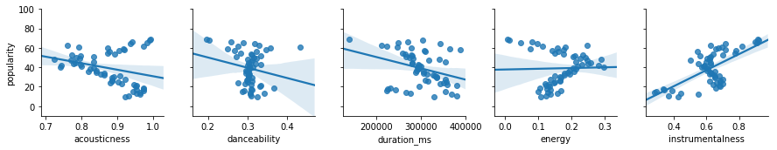

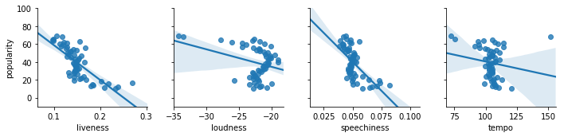

**Model Fitting**

To avoid overfitting, the data was split into training and test sets. A multivariate linear regression model was fitted using training data on a statsmodels.formula.api Ordinary Least Squares Regression model, with popularity as the predictor and variables with the strongest linear correlations from before.

results = smf.ols('popularity ~ acousticness + energy + instrumentalness + liveness', data = classicalTrainMean).fit()

Coefficients for each variable were obtained from minimizing:

$$∑{\left(Popularity-β_{0}-β_{1}x_{acoustic}-β_{2}x_{speech}-β_{3}x_{instru}-β_{4}x_{live}\right)}^{2 }$$

The interpretation of the regression coefficient is the estimated expected change in the outcome for a single unit change in the regressor with all other regressors held constant i.e. for $β_{1}$, it is the estimated change in popularity for a single unit change in acousticness. From our model's fit, we have:

Results: Ordinary least squares

=====================================================================

Model: OLS Adj. R-squared: 0.568

Dependent Variable: popularity AIC: 448.9744

Date: 2019-10-06 21:40 BIC: 459.2766

No. Observations: 58 Log-Likelihood: -219.49

Df Model: 4 F-statistic: 19.74

Df Residuals: 53 Prob (F-statistic): 5.34e-10

R-squared: 0.598 Scale: 124.06

---------------------------------------------------------------------

Coef. Std.Err. t P>|t| [0.025 0.975]

---------------------------------------------------------------------

Intercept 104.0369 18.9055 5.5030 0.0000 66.1174 141.9565

acousticness -59.0218 18.1056 -3.2599 0.0020 -95.3370 -22.7066

speechiness -143.6381 131.5060 -1.0923 0.2797 -407.4058 120.1296

instrumentalness 33.3890 12.5054 2.6700 0.0100 8.3064 58.4716

liveness -185.6042 47.3051 -3.9236 0.0003 -280.4861 -90.7222

---------------------------------------------------------------------

Omnibus: 0.959 Durbin-Watson: 0.494

Prob(Omnibus): 0.619 Jarque-Bera (JB): 1.001

Skew: -0.196 Prob(JB): 0.606

Kurtosis: 2.489 Condition No.: 134

=====================================================================

$$β_{0}=104.0,β_{1}=59.02,β_{2}=-143.6,β_{3}=33.39,β_{4}=-185.6$$

Predicted popularities were evaluated using the model on both the training and test set, and the mean squared error was evaluated. Results predicted from the training set and the testing set achieved $r^{2}$ coefficients of 0.598 and 0.563, and Mean-squared errors of 113.36 and 123.04 respectively.

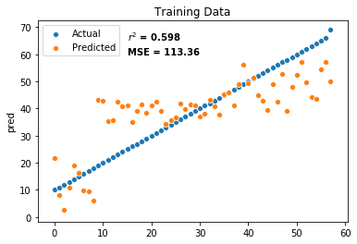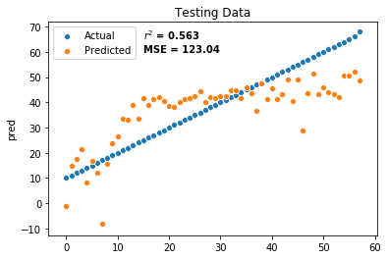

**Interpretation**

Thus, we have obtained a model that predicts a Classical song’s popularity relatively accurately based on song metrics such as acousticness, speechiness, instrumentalness and liveness. It may thus be possible to predict the popularity of a new (Classical) song on spotify by analyzing the metrics and using the model. From the model, it appears that less speech and liveness (i.e. a better recording) and greater instrumentation tends to correlate with a higher popularity.

However, we do note that the model only applies to a subset of songs – specifically, I removed songs with less than 20 popularity from analysis, in other to obtain a less skewed distribution of song popularity. In addition, further analysis can be done to identify more features that affect song popularity, such as Key or Mode (in supplementary data, not in linear regression). Lastly, this form of analysis can also be applied to the other 26 song genres in the data set, to identify any interesting trends.

1. https://developer.spotify.com/documentation/web-api/reference/tracks/get-several-audio-features/